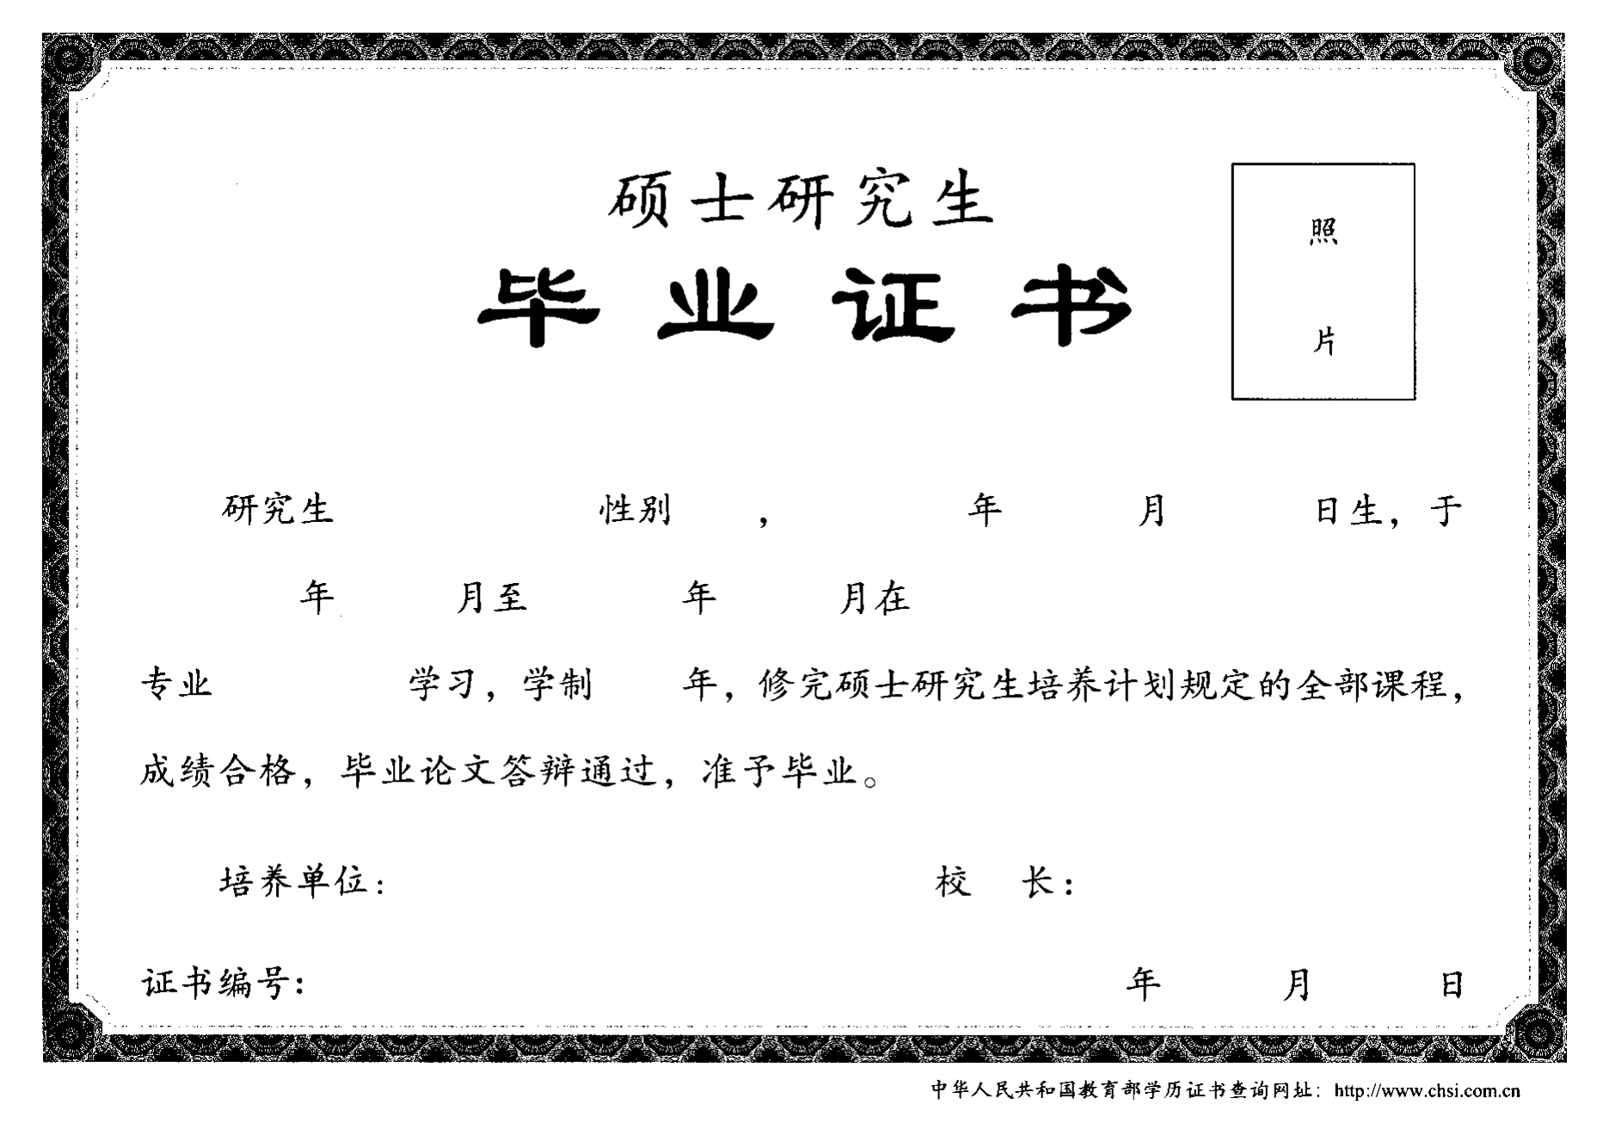
(毕业证书原件扫描粘贴此处)
(Translation)
Liaoning University
THIS IS TO CERTIFY THAT

Xu Kaili
Female, born on July 20, 1994, majored in Juris Master (for law graduates) in this university from September 2015 to June 2017. Upon her completing all the required courses of 2-year postgraduate program and getting her thesis approved, she is hereby qualified to graduate.

President Pan Yishan
June 30, 2018
Diploma number: 1014012018000000
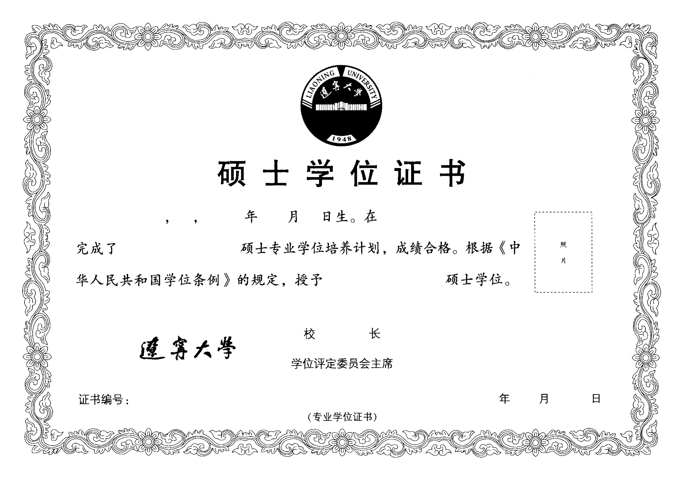
(学位证书原件扫描粘贴此处)
(Translation)
Liaoning University

THIS IS TO CERTIFY THAT

Xu Kaili
Female, born on July 20, 1994, majored in Juris Master in this university, has completed the professional postgraduate program.
In accordance with “The Regulations Concerning Academic Degrees in the People's Republic of China”, she is conferred the Master’s Degree of Juris Master.
President
Pan Yishan

Chairman of Academic Degrees Committee
June 30, 2018
Certificate number : 1014032018000001

(Professional Degree Certificate)

