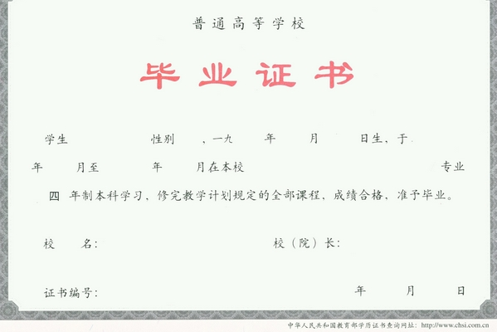
(毕业证书原件扫描粘贴此处)

(Translation)
Liaoning University
THIS IS TO CERTIFY THAT

Zhang Shan
Female, born on May 23, 1993, majored in International Economics and Trade in this university from September 2011 to July 2015. Having completed the four-year undergraduate program and passed the examinations, she is hereby allowed to graduate.
Pan Yishan
President
July 10, 2015
Diploma number: xxxxxxxxxxxxxxxxxx
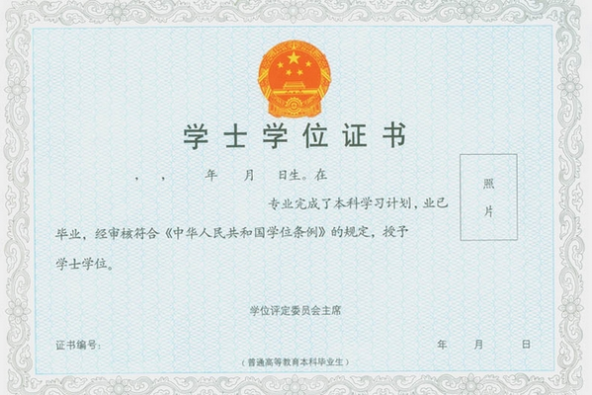
(学位毕业证书原件扫描粘贴此处)
(Translation)
Liaoning University

THIS IS TO CERTIFY THAT

Zhang Shan
Female, born on May 23, 1993, majored in International Economics and Trade in this university, having completed the undergraduate program, she is hereby allowed to graduate.
In accordance with “The Regulations Concerning Academic Degrees in the People's Republic of China”, she has conferred the degree of Bachelor of Economics.
President
Pan Yishan

Chairman , Degree Awarding Committee
July 10, 2015
Certificate number :xxxxxxxxxxxxxxxx

